Lab 2: Containerization & Kubernetes Orchestration
Task 2: Manage Docker containers and images

1. Objective
Demonstrate the day-to-day Docker container/image management workflow: listing, starting, stopping and removing containers; tagging an image and pushing/pulling it to/from a registry; and running a multi-container application with Docker Compose.

2. Listing, Starting, Stopping and Removing Containers
Using the lab2-python-app:1.0 image built in Task 1, the container lifecycle was exercised end-to-end. Run each command in order and screenshot the whole sequence:
docker ps -a --filter name=lab2
docker stop lab2-app
docker ps -a --filter name=lab2
docker start lab2-app
docker ps --filter name=lab2
docker stop lab2-app
docker rm lab2-app
docker ps -a --filter name=lab2
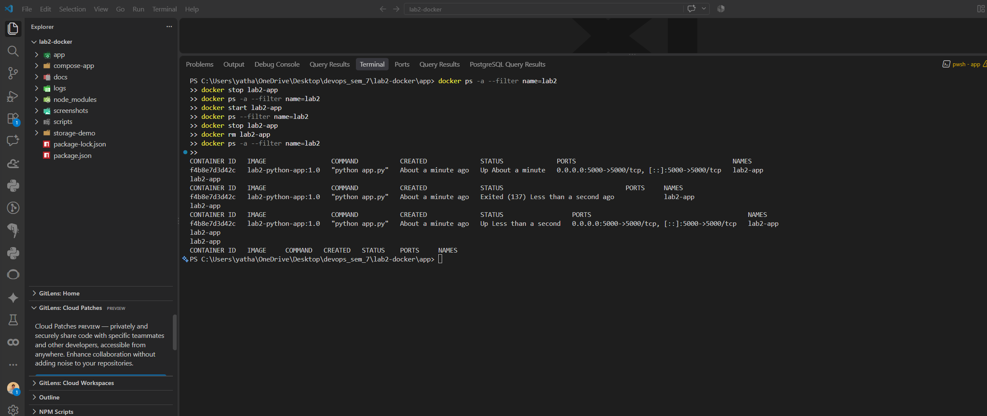

- docker ps -a lists all containers regardless of state (running or exited).
- docker stop sends SIGTERM to the container's PID 1, which reports as Exited (137) once terminated.
- docker start resumes the same (stopped) container without recreating it — same container ID, fresh Up status.
- docker stop + docker rm together permanently delete the container object; docker ps -a then shows nothing for that name.
docker images continues to list the underlying image (lab2-python-app:1.0, 208 MB) independently of whether any container based on it currently exists — images and containers have separate lifecycles.

3. Tagging and Pushing an Image to a Registry
To demonstrate docker tag / docker push without requiring a personal Docker Hub account or entering any account credentials, a local Docker registry (the official registry:2 image) was run as a container on port 5050 and used as the push/pull target — this is the standard offline-friendly way to exercise the registry workflow.
docker run -d -p 5050:5000 --name lab2-registry registry:2

docker tag lab2-python-app:1.0 localhost:5050/lab2-python-app:1.0
docker images lab2-python-app

docker push localhost:5050/lab2-python-app:1.0
curl.exe -s http://localhost:5050/v2/lab2-python-app/tags/list
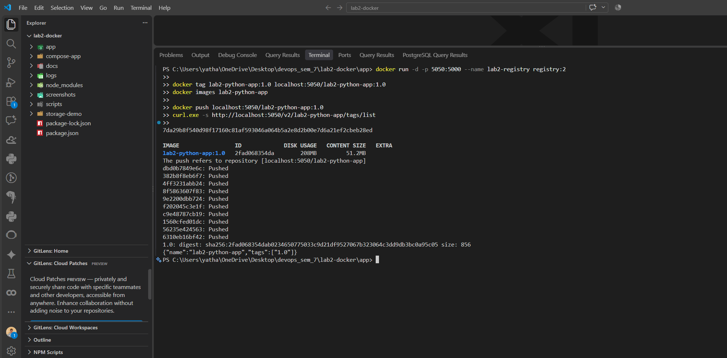

Step | Command | Result
1. Start local registry | docker run -d -p 5050:5000 --name lab2-registry registry:2 | Registry container listening on localhost:5050
2. Tag the image | docker tag lab2-python-app:1.0 localhost:5050/lab2-python-app:1.0 | New tag added, same image ID (95bee46b7932) as Task 1
3. Push | docker push localhost:5050/lab2-python-app:1.0 | 10 layers pushed; digest sha256:95bee46b7932...
4. Verify | curl localhost:5050/v2/lab2-python-app/tags/list | {"name":"lab2-python-app","tags":["1.0"]}
5. Round-trip | docker rmi <tag> && docker pull localhost:5050/lab2-python-app:1.0 | Image re-downloaded successfully from the local registry

docker tag does not copy any data — it adds a second name (repository:tag) pointing at the same image ID, which is why docker images shows lab2-python-app:1.0 and localhost:5050/lab2-python-app:1.0 with an identical IMAGE ID and identical size. Only docker push actually transfers the image layers to the registry.

4. Multi-Container Setup with Docker Compose
A second, Compose-managed application (compose-app/) was created with two services — a Flask web service and a Redis cache — to demonstrate multi-container orchestration from a single docker-compose.yml file.
services:
web:
build: ./web
image: lab2-compose-web:1.0
container_name: lab2-compose-web
ports:
- "5001:5000"
environment:
- REDIS_HOST=redis
depends_on:
- redis

redis:
image: redis:7-alpine
container_name: lab2-compose-redis
expose:
- "6379"

The web service increments a counter stored in Redis (r.incr("visits")) on every request, using the Redis service's Compose service name (redis) as the hostname — proving both containers were started, networked together, and could communicate purely through Compose configuration.
cd lab2-docker\compose-app
docker compose up -d --build
docker compose ps

curl.exe -s http://localhost:5001/
curl.exe -s http://localhost:5001/health

docker compose down
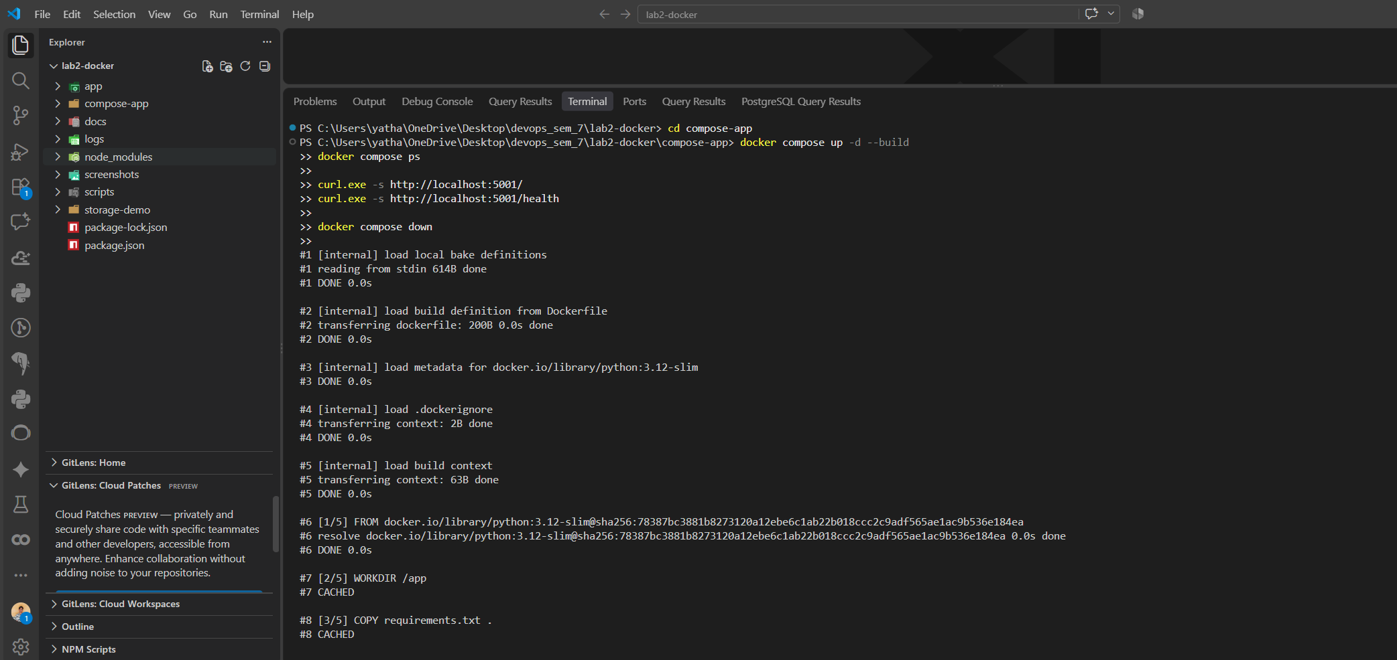

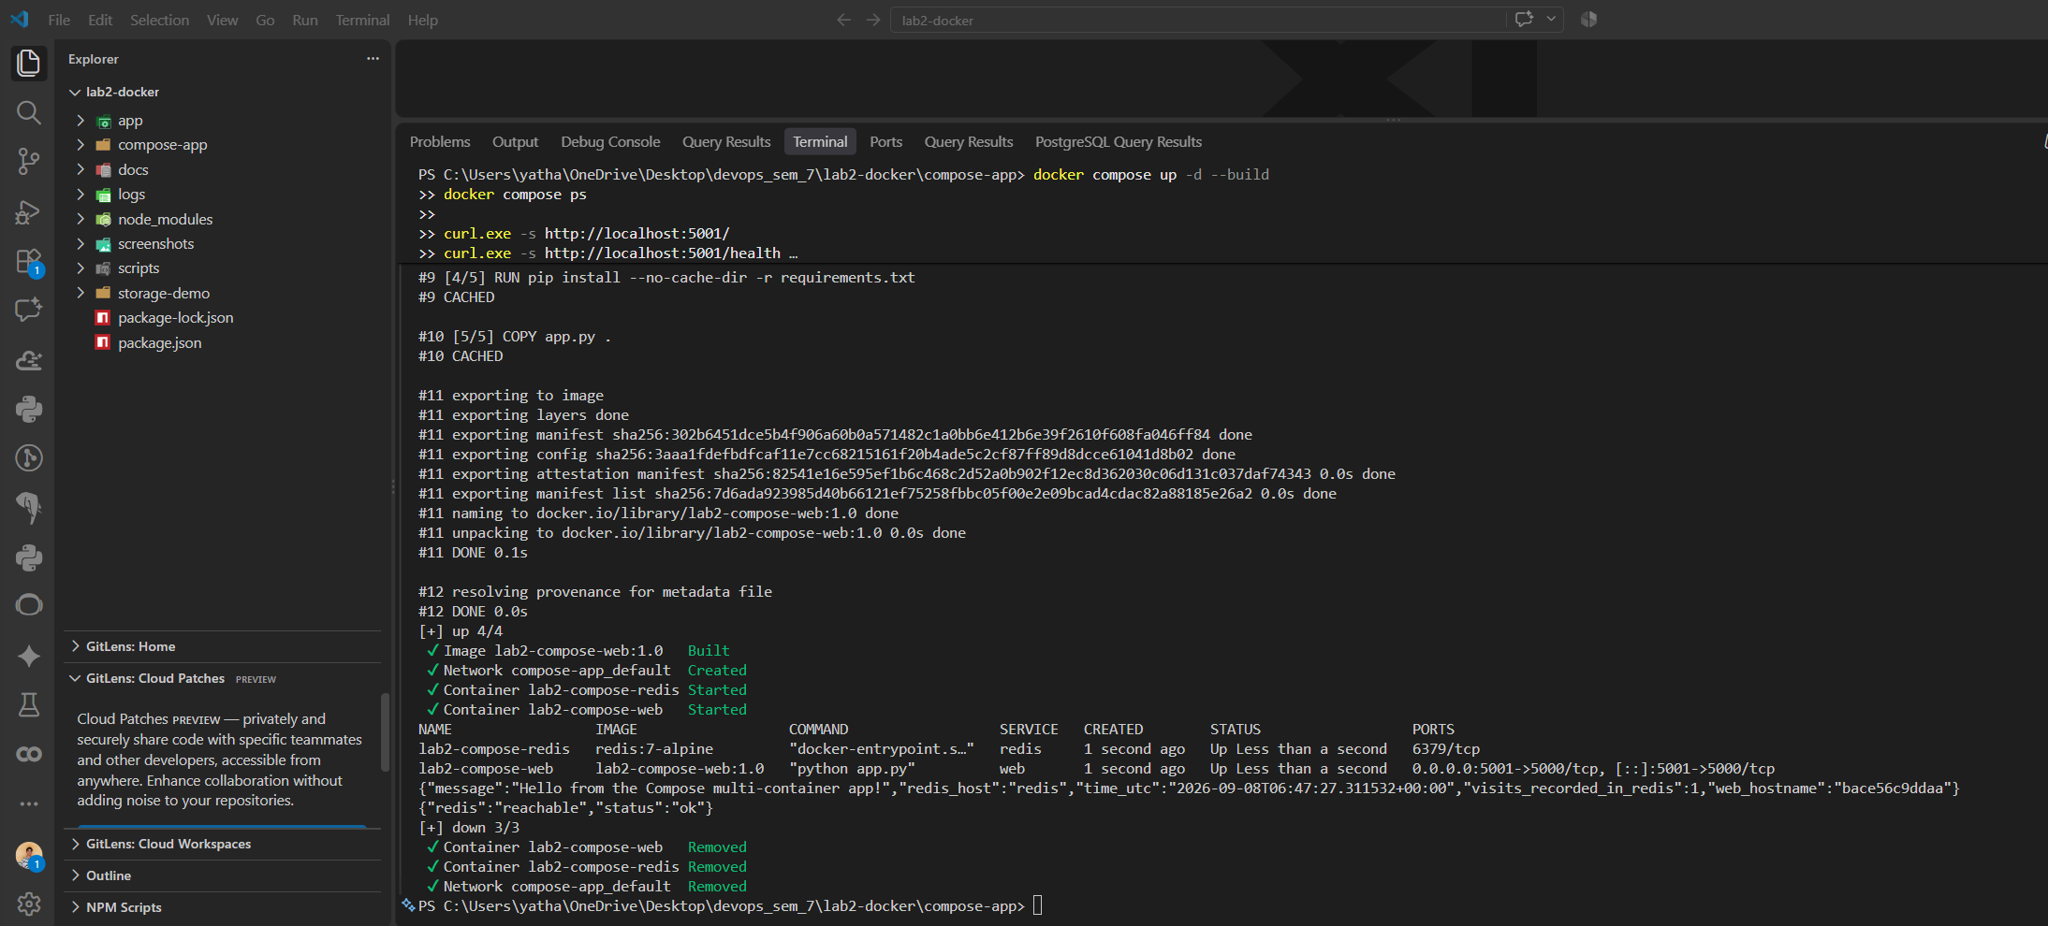

Command | Purpose | Result
docker compose up -d --build | Build the web image and start both services | Network compose-app_default created; both containers Started
docker compose ps | List services managed by this Compose project | lab2-compose-redis and lab2-compose-web both Up
curl localhost:5001/ (x3) | Exercise the web service | visits_recorded_in_redis increased 1, 2, 3 — proving Redis connectivity
curl localhost:5001/health | Check Redis reachability from web | {"redis":"reachable","status":"ok"}
docker compose down | Stop and remove containers + network | Both containers and the compose network were removed

5. Conclusion
The full container/image management surface required by this task was exercised against real, running containers: lifecycle management (ps/start/stop/rm), image tagging, pushing/pulling against a registry, and a genuine multi-container deployment orchestrated with Docker Compose, including verified inter-container communication between the web and redis services.

